Updating NMRS PBS Service on Linux

This document assumes that the pbs service is running on the host computer according to the pbs installation guide. Before you start kindly download the latest version of the PBS service for linux.

Note: use this web address (localhost:2018/server) to track the update process, before and after update.

1. Stop the NMRS PBS service : *sudo systemctl stop nmrs-biometric.service*
2. Delete the nmrs-biometric.jar file from this location: /opt/nmrs-deploy
3. Copy the nmrs-biometric.jar file from the latest version folder to /opt/nmrs-deploy/
4. Restart the systemctl daemon: sudo systemctl daemon-reload
5. Start the nmrs-biometric service: sudo systemctl start nmrs-biometric.service.
6. Visit this localhost:2018/server to confirm the app version.

The photo below summarizes the above process:

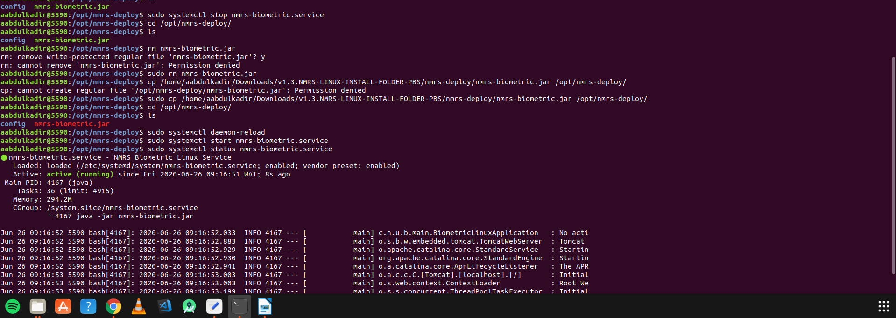

Biometric service details check

